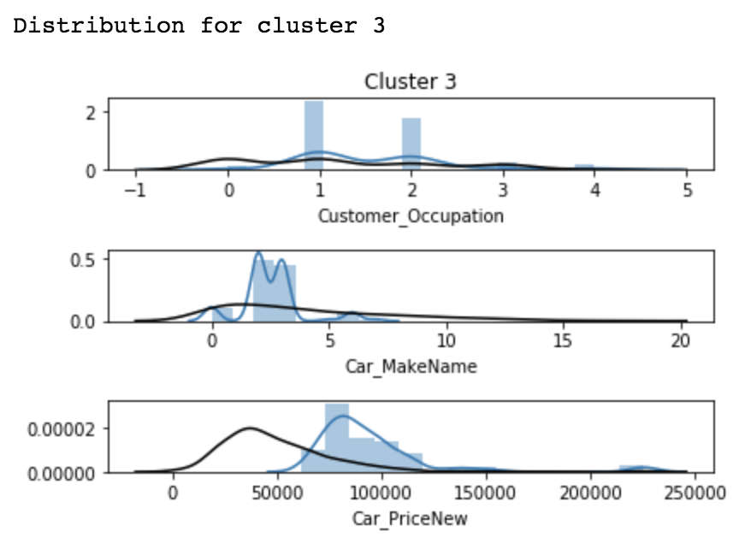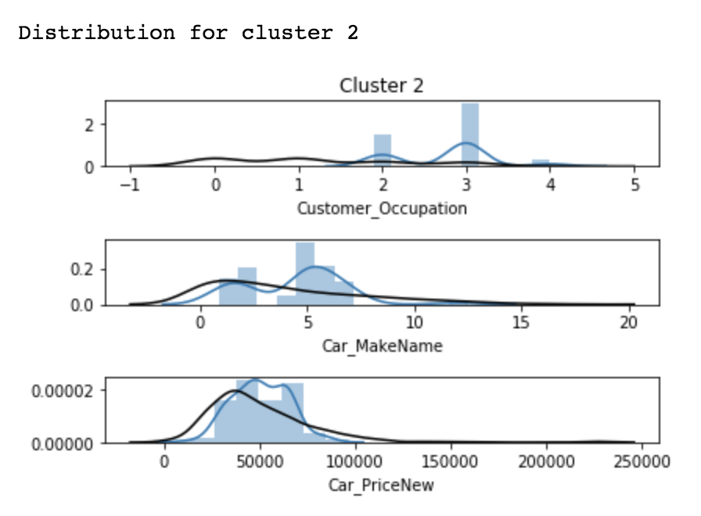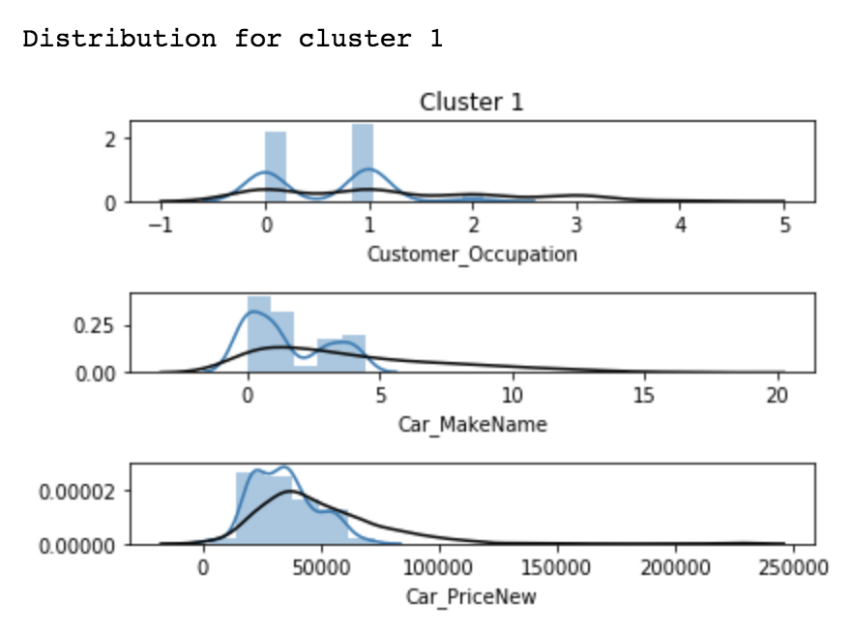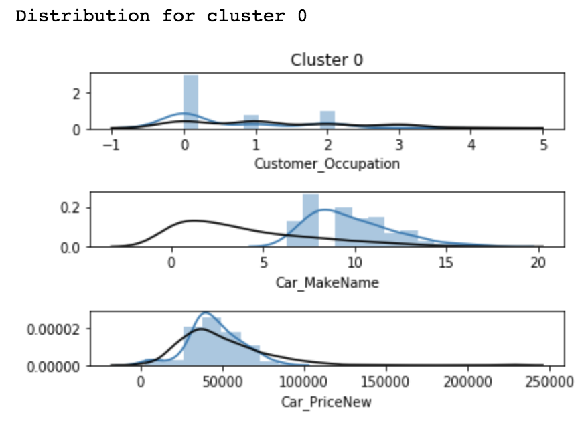

**Customer Occupation**

MANAGER = 0

LABOUR = 1

RETIREE = 2

NURSE = 3

RESEARCHER = 4

**Car Make Name**

SEDAN = 0

HATCHBACK = 1

WAGON = 2

COUPE = 3

CABRIOLET = 4

HATCHBACK = 5

HARDTOP = 6

VAN = 7

ROADSTER = 8

CONVERTIBLE = 9

HARDBACK = 10